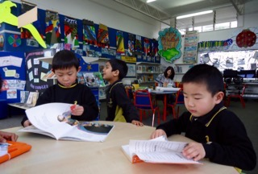
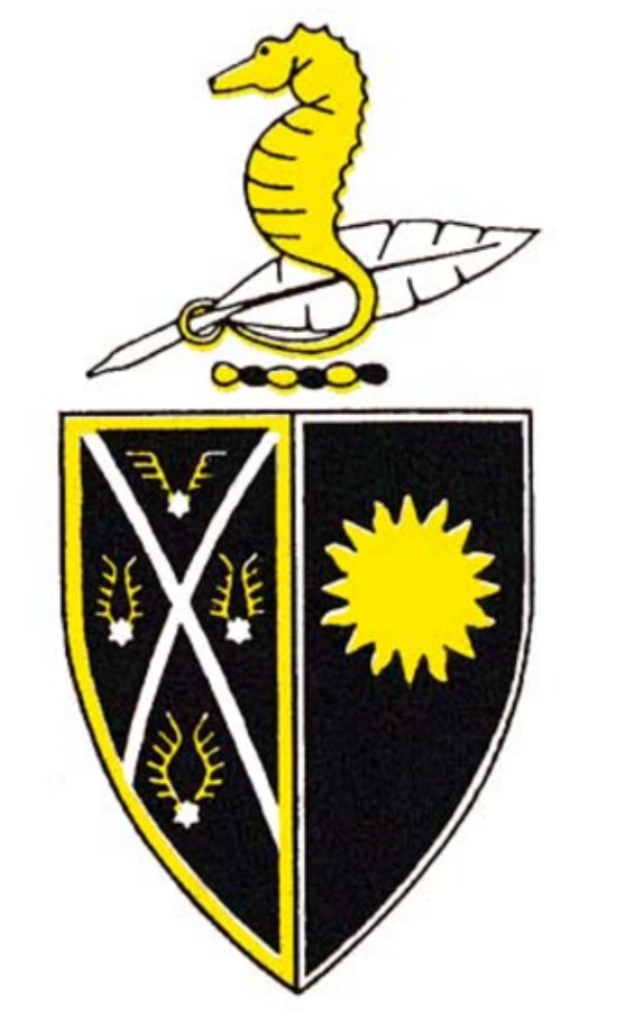
Reminders - Week beginning 30 July 2018

Welcome this week to: Fale Palei (R1) and Angela Wu (R6)

Student-led Parent Teacher Conferences
We are looking forward to seeing you for your scheduled conferences this week on Wednesday from 3:15 pm and on Thursday from 1:30 pm. All students must be collected at 12:30 pm on Thursday (unless prior arrangements have been made with KidsKlub). If you have not yet made a booking for your child’s conference, please call the office and we will help you out.

Math-a-thon Fundraiser
We hope all of our students are learning their Math-a-thon facts that they were given last week. Last Friday, the students who have managed to get 6 or more sponsors were given a small prize. Prizes will be given out again this coming Friday to any who have not yet been acknowledged for having 6 or more sponsors.

Celebrating Sport at Sunnybrae
The Year 6 SNS Stingers Basketball team came 4th place in their Semester 1 Championship Grade played at the YMCA. Well done to Tamaso Vaenuku, Nati Leykune, Tai Mataora, Olly Straight, Riley Mail, Joshua Haythornthwaite, Thomas Jones and Hauli Palei. Thanks to their coach, Kirstin Mail and manager, Chantal Straight.

Cook Islands Language Week
We will be celebrating this week at Sunnybrae in the following ways:
- displaying some artefacts in the library.
- encouraging the children to dress in their traditional clothing on Wednesday 1 August.
- inviting the children to participate in some activities throughout the week run by Mrs Winnie Ngata (Teacher Aide).
- encouraging children to share some simple vocabulary with their classmates.
Fun Facts:
- There are more Cook Islands Māori living in New Zealand than there are in all of the Cook Islands combined.
- The Cook Islands Māori ethnic group is the second largest Pacific population in New Zealand and accounts for 1.5% of the total population.

MESSAGE FROM AUCKLAND TRANSPORT

Before and after school is a busy time for everyone. Parking rules help protect our children and keep them safe. Drivers who park illegally put our children at risk.

This term parking officers will be on patrol outside Sunnybrae School to issue tickets to those who are illegally parked.

Fines for illegal parking include:

- Parked on the footpath or grass verge/berm $40
- Parked across or within 1 metre of a vehicle entrance $40
- Parked within 6 metres either side of a bus stop $40
- Parked within a marked bus stop $60
- Double parked $60
- Inconsiderate parking $60
- Parked on a pedestrian crossing $60
- Parked on a yellow line $60

PLEASE NOTE: The parking area behind the Sunnybrae shops is private property and is not to be used by school parents for parking.

Thank you for your co-operation.

AUCKLAND TRANSPORT

Community Notices
- Kumon Glenfield & Birkenhead Reading and Maths Tuition - free trial offered in August. Please phone Josephine Wong on 021 182 3293 if you are interested.
- Rugby (non contact) Skills Clinic - 5 weekly sessions being held at Sunnybrae, starting on Monday 20th August from 3:10-3:55 pm. Cost $49 per child, $24 per extra sibling. For enrolments and further information please visit www.footballkidznz.co.nz or pick up a leaflet from the office foyer.
- Places available in the Milford Sea Scout Kea group (for children aged 5 - 8 and also in the Milford Cubs group. For further information phone Christien on 027 663 6782 or email christiengriffith426@gmail.com.
- The Kelly Sports programme for Year 0 - 5 students is offered at Sunnybrae School for 7 weeks (commencing tomorrow). Cost $75. The programme is run each Tuesday from 3:10 - 4:10 pm. Sports covered this term include football, turbo touch, dodgeball and basketball. For further information visit www.kellysports.co.nz/glenfield-birkenhead or phone Felicia on 022 533 5420.

On 1 August each year, we celebrate the annual SCOUT Scarf Day and encourage members to wear their scarves to school for the day to promote the uniqueness and many opportunities SCOUTS New Zealand can offer youth and adults alike.
With around 350 groups and more than 19,000 current members, there is a good chance someone in your neighbourhood or school will be wearing their Scout scarf on SCOUT Scarf Day.

